## Pre-Processor and Post-Processor in JMeter

A processor is used to modify the Samplers in their scope.

There are 2 Types of processors:

1. Pre-processor
2. Post-processor

## Pre-processor:

Pre-processor executes some action **before** making Sampler Request.

Consider a simple example: let’s say you wanted JMeter to “spider” through the website under test, **parse**link(check all links on the page) and **return** the HTML. You would add some action such as “HTML link parser” to your controller before creating an HTTP request.



## Post-processor:

Post-processor executes some action after making a Sampler Request.

Consider a simple example: JMeter sends an HTTP request to the web server under test (etc www.google.com) and get the response. You want JMeter to stop the test if the server response is an error. You can use the post-processor to do above task as follows:

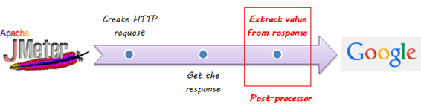

## Post Processor Example

This tutorial will show you step-by-step instructions on how to use Post-processor in JMeter. Let start with the simple test script.

1. JMeter sends an HTTP request to the web server under test www.google.com.
2. JMeter gets a response from the Google server.
3. If server response is **an error**, JMeter will **stop** the test.
4. If server response **OK** (no error), JMeter will **continue** the test.

Here is the **roadmap** of this example:

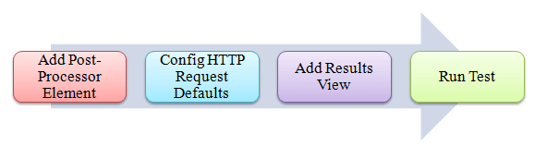

**Pre-condition:**

We **re-use** the Step 1 and Step 2 in article JMeter Performance Testing.

## Step 1) Add Thread Group

Right click on the Test Plan and add a new thread group: **Add**-> **Threads (Users)** -> **Thread Group**

But in Thread Group control panel, enter Thread Properties as follows:

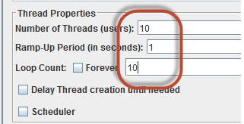

This setting lets JMeter create **10** user request to http://www.google.com **10** times.

## Step 2) Add JMeter elements

* Add HTTP request default
* Add HTTP request

We still make JMeter send request http://www.google.com to Google server.

## Step 3) Add Post-Processor Element

Right Click **Thread Group**->**Add**->**Post Processor**->**Result Status Action Handler**

**Result Status Action Handler** allows the user to stop the thread or the whole test if the user request failed.

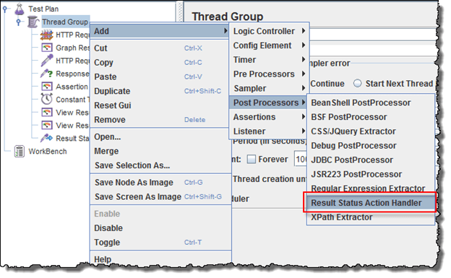

In Result Status Action Handle Pane, choose **Stop Test Now**. This selection will stop the test if JMeter get the error from server response.

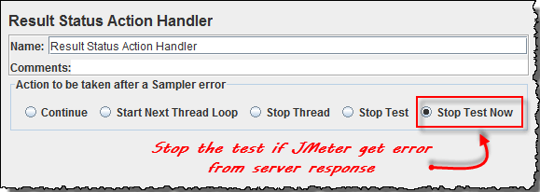

## Step 4) Config the HTTP Request

Open the HTTP Request Panel. Enter **“abc”** to the Path field.

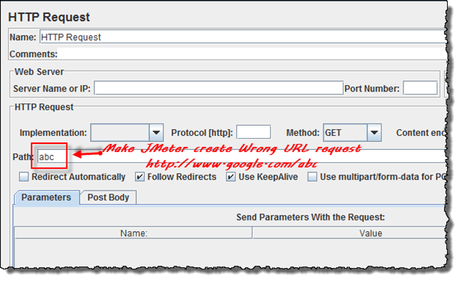

When you enter **“abc”** to the path, JMeter will create a URL request to Google server: http://www.google.com/abc. This URL doesn’t exist on Google server. It is **wrong** URL request so Google server will return an error.

## Step 5) Add View Result Tree

Right Click **Thread Group**->**Add**-> **Listener**-> **View Result Tree**

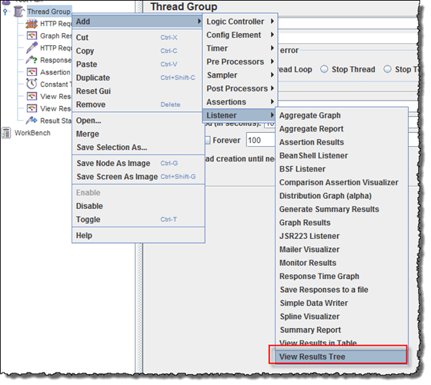

## Step 6) Run Test

Select View Result Tree, press Run button on Menu bar. You will see the **error** response from Google server and the test will stop **with out** completing 100 threads.

Now return to step 4, open the HTTP Request pane, enter “**calendar**” to the pane. It makes JMeter create URL request https://calendar.google.com/calendar/u/0/r to the Google server. This is **correct** URL request so Google server will return OK (no error).

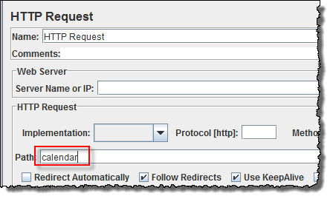

Select View Result Tree, press Run button on Menu bar. You will see the **OK** response from Google server and the test will continue until all 100 threads are complete.